**Weekly Review #6 Name: _______________________**

**SHOW ALL WORK**

**1.** **Give all your numerical answers correct to two decimal places.**

On 1 January 2005, Daniel invested 30 000 AUD at an annual **simple** interest rate in a *Regular Saver* account. On 1 January 2007, Daniel had 31 650 AUD in the account.

(a) Calculate the rate of interest.

(3)

On 1 January 2005, Rebecca invested 30 000 AUD in a *Supersaver* account at a nominal annual rate of 2.5 % **compounded annually**.

(b) Calculate the amount in the *Supersaver* account after two years.

(3)

(c) Find the number of complete years since 1 January 2005 it will take for the amount in Rebecca’s account to exceed the amount in Daniel’s account.

(3)

On 1 January 2007, Daniel reinvested 80 % of the money from the *Regular Saver* account in an *Extra Saver* account at a nominal annual rate of 3 % **compounded quarterly**.

(d) (i) Calculate the amount of money reinvested by Daniel on the 1 January 2007.

(ii) Find the number of complete years it will take for the amount in Daniel’s *Extra Saver* account to exceed 30 000 AUD.

(5)

(Total 14 marks)

**2.** The heat output in thermal units from burning 1 kg of wood changes according to the wood’s percentage moisture content. The moisture content and heat output of 10 blocks of the same type of wood each weighing 1 kg were measured. These are shown in the table.

|  |  |  |  |  |  |  |  |  |  |  |
| --- | --- | --- | --- | --- | --- | --- | --- | --- | --- | --- |
| **Moisture content % (*x*)** | 8 | 15 | 22 | 30 | 34 | 45 | 50 | 60 | 74 | 82 |
| **Heat output ( *y*)** | 80 | 77 | 74 | 69 | 68 | 61 | 61 | 55 | 50 | 45 |

(a) Draw a scatter diagram to show the above data. Use a scale of 2 cm to represent 10 % on the *x-*axis and a scale of 2 cm to represent 10 thermal units on the *y-*axis.

(4)

(b) Write down

(i) the mean percentage moisture content, ;

(ii) the mean heat output, *.*

(2)

(c) Plot the point ()on your scatter diagram and label this point M.

(2)

(d) Write down the product-moment correlation coefficient, *r.*

(2)

The equation of the regression line *y* on *x* is *y* = –0.470*x* + 83.7.

(e) Draw the regression line *y* on *x* on your scatter diagram.

(2)

(f) Estimate the heat output in thermal units of a 1 kg block of wood that has 25 % moisture content.

(2)

(g) State, with a reason, whether it is appropriate to use the regression line *y* on *x* to estimate the heat output in part (f).

(2)

(Total 16 marks)

**3.** A university required all Science students to study one language for one year.  
A survey was carried out at the university amongst the 150 Science students. These students all studied one of either French, Spanish or Russian. The results of the survey are shown below.

|  |  |  |  |
| --- | --- | --- | --- |
|  | **French** | **Spanish** | **Russian** |
| **Female** | 9 | 29 | 12 |
| **Male** | 31 | 40 | 29 |

Ludmila decides to use the *χ*2 test at the 5 % level of significance to determine whether the choice of language is independent of gender.

(a) State Ludmila’s null hypothesis.

(1)

(b) Write down the number of degrees of freedom.

(1)

(c) Find the expected frequency for the females studying Spanish.

(2)

(d) Use your graphic display calculator to find the χ2 test statistic for this data.

(2)

(e) State whether Ludmila accepts the null hypothesis. Give a reason for your answer.

(2)

(Total 8 marks)

**4.** In the diagram, AD = 4 m, AB = 9 m, BC = 10 m,  = 90° and  = 100°.

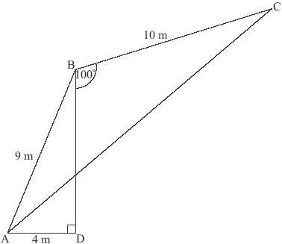

***diagram not to scale***

(a) Calculate the size of .

(3)

(b) Calculate the length of AC.

(3)

(Total 6 marks)

**5.** The function *f*(*x*)is defined by *f*(*x*) = 1.5*x* + 4 + , *x* ≠ 0.

(a) Write down the equation of the vertical asymptote.

(2)

(b) Find *f*′’(*x*).

(3)

(c) Find the gradient of the graph of the function at *x* = –1.

(2)

(d) Using your answer to part (c), decide whether the function *f*(*x*)is increasing or decreasing at *x* = –1. Justify your answer.

(2)

(e) Sketch the graph of *f*(*x*)for –10 ≤ *x* ≤ 10 and –20 ≤ *y* ≤ 20.

(4)

P1 is the local maximum point and P2 is the local minimum point on the graph of *f*(*x*)*.*

(f) Using your graphic display calculator, write down the coordinates of

(i) P1;

(ii) P2.

(4)

(g) Using your sketch from (e), determine the range of the function *f*(*x*)for –10 ≤ *x* ≤ 10.

(3)

(Total 20 marks)

**6.** The sets *P*, *Q* and *U* are defined as

*U* = {Real Numbers}, *P* = {Positive Numbers} and *Q* = {Rational Numbers}.

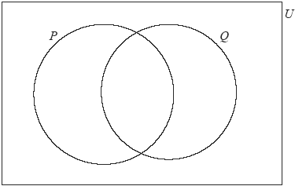

Write down in the correct region on the Venn diagram the numbers

, 5 × 10–2 , sin(60°) , 0 ,  , –π

(Total 6 marks)